Anion Chemistry on Titan: A possible route to large hydrocarbons

Jan Žabka*, Miroslav Polášek*, Věra Křížová*, Illia Zymak*, Claire Romanzin†, Christian Alcaraz†
* J. Heyrovský Institute of Physical Chemistry of the ASCR, v. v. i., Dolejškova 3, Prague 8, 182 23, Czech Republic
†Laboratoire de Chimie Physique, Bât 350, Centre Universitaire Paris-Sud, 91405 Orsay, France
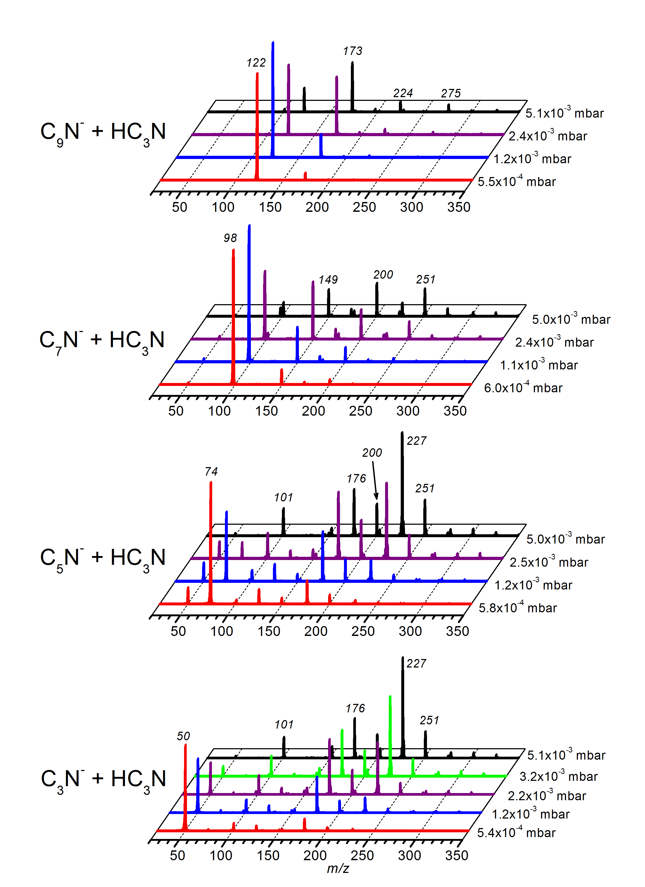
Synopsis The reactions of C_{2n+1}N⁻anions and their complexes with cyanoacetylene, HC₃N, and hydrogen cyanide, HCN, were studied experimentally using methods of tandem mass spectrometry. The reactions described in detail in this communication may represent a possible way of formation of large anions found in the ionosphere of Titan.

Cassini CAPS-ELS spectrometer revealed the presence of large negative ions in the ionosphere of Titan [1]. Recently, a mechanism has been proposed for the possible formation of these ions, in whith the cyanoacetylene, HC₃N, played a key role [2]. Chemical ionization technique (NCI and APCI-) were used successfully to prepare model complex (HC₃N)_{x}.C_{y}N⁻ anions in the gas phase. The reaction itself and CID experiments was studied using a Waters Quattro Premier TM tandem quadruple mass spectrometer operating in negative ion mode and VG ZAB2-SEQ mass spectrometer. CID mass spectra of these anions, as well as their ion molecule reactions with HC₃N support the previously proposed reaction scheme [2,3]. Quantum chemistry calculations revealed details of the ion structures, energetics and reaction mechanisms. High-energy CID spectra of (HC₃N)_{x}.C_{y}N⁻ anions showed a complexity of ionic and neutral products that can be expected to be formed by the high-energy ion precipitation observed at Titan [4].

Presented experiments show that in spite of its low abundance in Titan atmosphere [5], the cyanoacetylene is probably one of the most important species in the ionospheric chemistry of Titan.

Acknowledgement

This work was supported by the Czech Science Foundation (grant No.14-19693S), the Ministry of Education Youth and Sports of Czech Republic (grant No. LD14024), the RTRA “Triangle de la Physique (project GIN) and the French planetology program (PNP).

Figure 1. Pressure dependent mass spectra of reactions of C_{x}N⁻ anions (x =3,5,7,9) with HC₃N.

References
[1] A.J. Coates et al 2007 Geophys. Res. Lett. 34 L22103
[2] J. Žabka, M. Polášek, C. Romanzin, C. Alcaraz 2012
Icarus 219 161
[3] J. Žabka, I. Ndiaye, C. Romanzin, C. Alcaraz, M.
Polášek, 2014 Int. J. Mass Spectrom. 367 1
[4] T.E. Cravens et al 2008 Geophys. Res. Lett. 35
L03103
[5] V. Vuitton et al 2009 Planet. Space Sci. 57 15587

E-mail: jan.zabka@jh-inst.cas.cz

